20/10/2022

**PHP TASK -1**

1.

<?php

$alphabet=range('A','Z');

for($i=0;$i<5;$i++)

{

for($j=0;$j<=$i;$j++)

{

echo $alphabet[$i];

}

echo "<br>";

}

?>

Ouput :

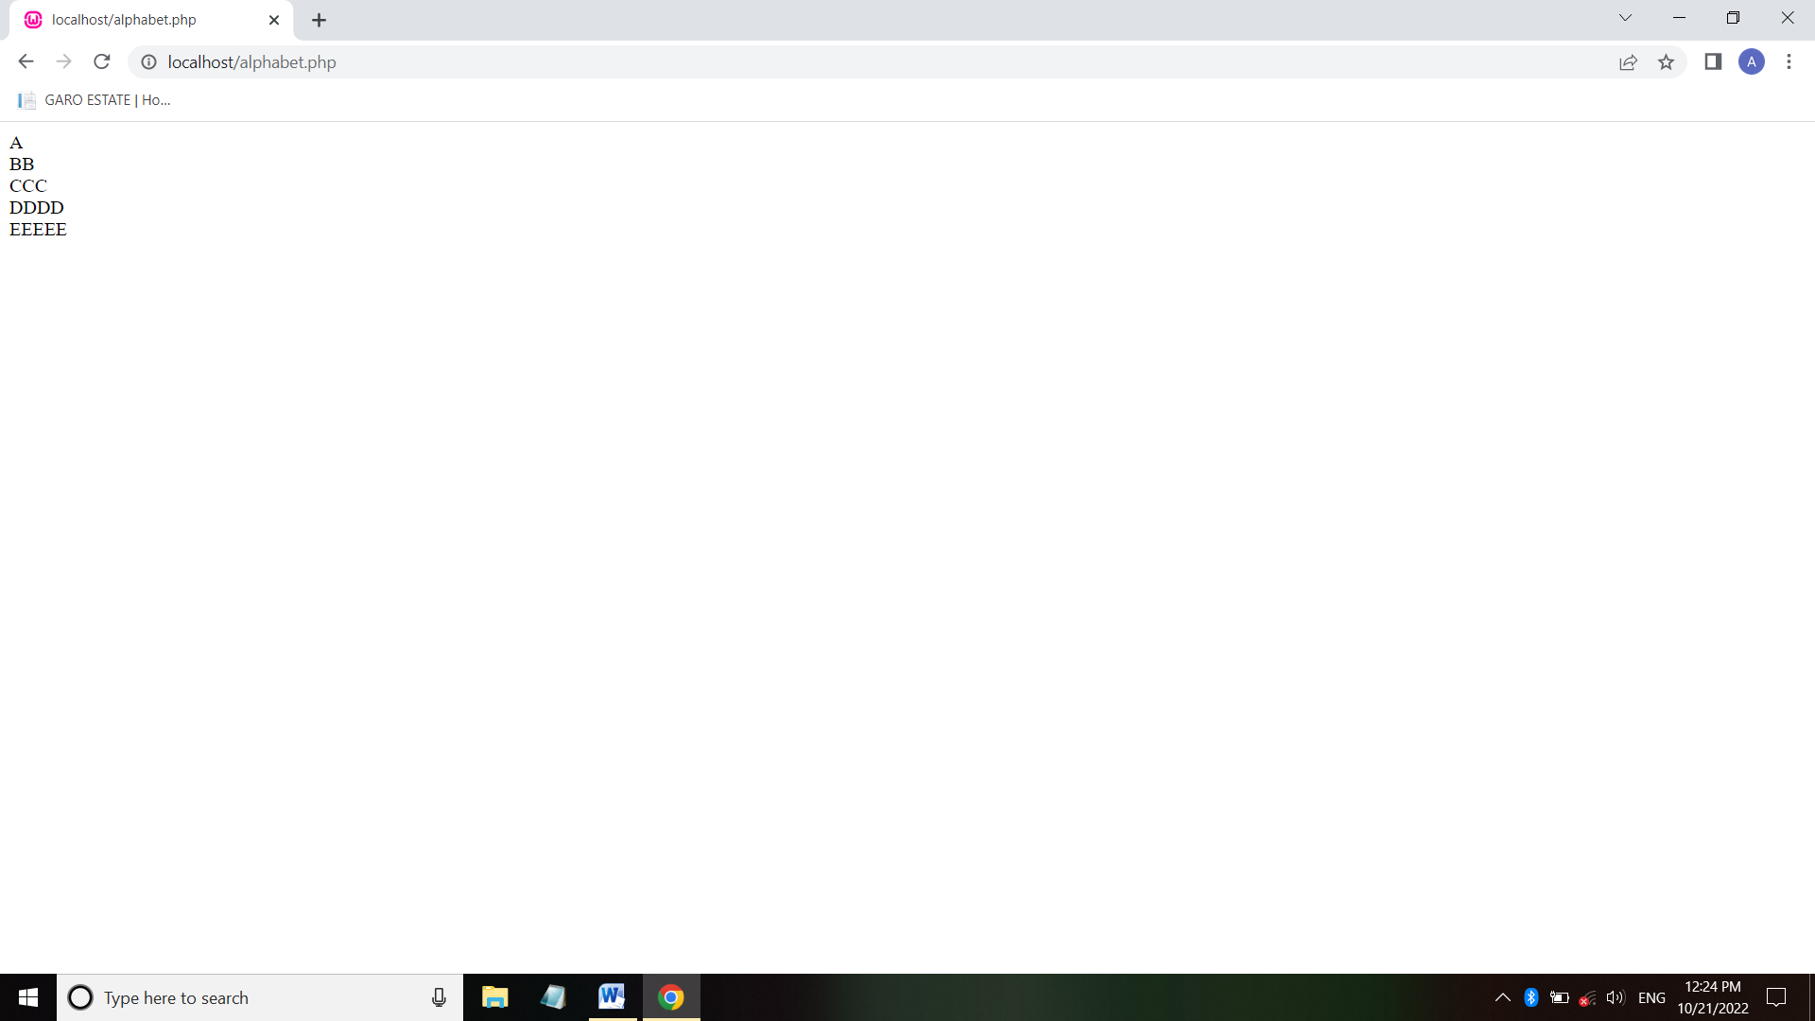



<?php

for($i=0;$i<=5;$i++)

{

for($j=1;$j<=$i;$j++)

{

echo"1"; "<br>";

}

echo "<br>";

}

?>

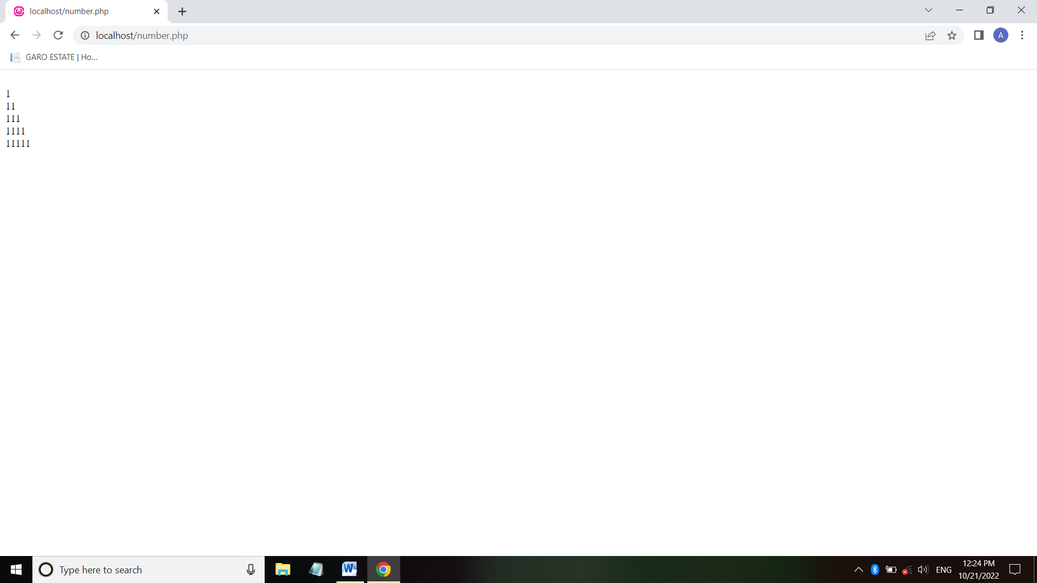



<?php

$num=14597;

$sum=0;$rem=0;

for($i=0;$i<=strlen($num);$i++)

{

$rem=$num%10;

$sum=$sum+$rem;

$num=$num/10;

}

echo "Sum of digits 14597 is $sum";

?>



<?php

$number=1233456;

if($number%2==0)

{

echo "$number is Even number";

}

else

{

echo "$number is Odd number";

}

?>

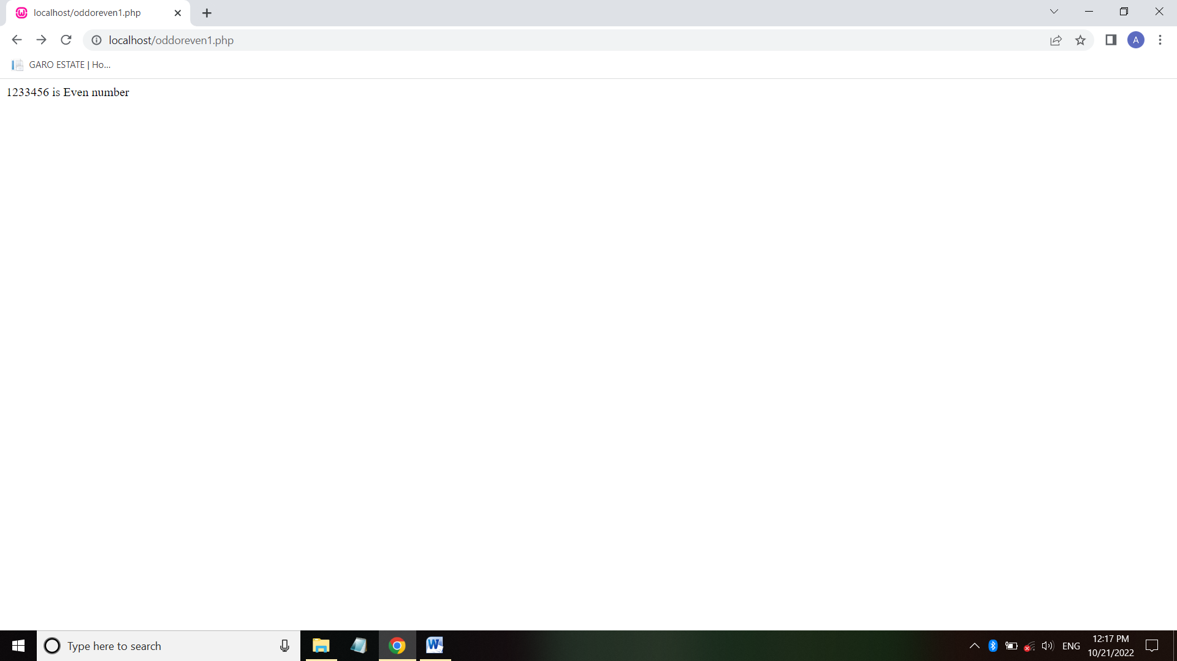

1. Odd or even

<html>

<body>

<form method ="post">

Enter a number : <input type = "number" name ="number">

<input type = "Submit" name ="submit">

</form>

</body>

</html>

<?php

if($_POST)

{

$number = $_POST['number'];

if (($number %2)==0)

{

echo "$number is an Even number";

}

else

{

echo "$number is an odd number";

}

}

?>

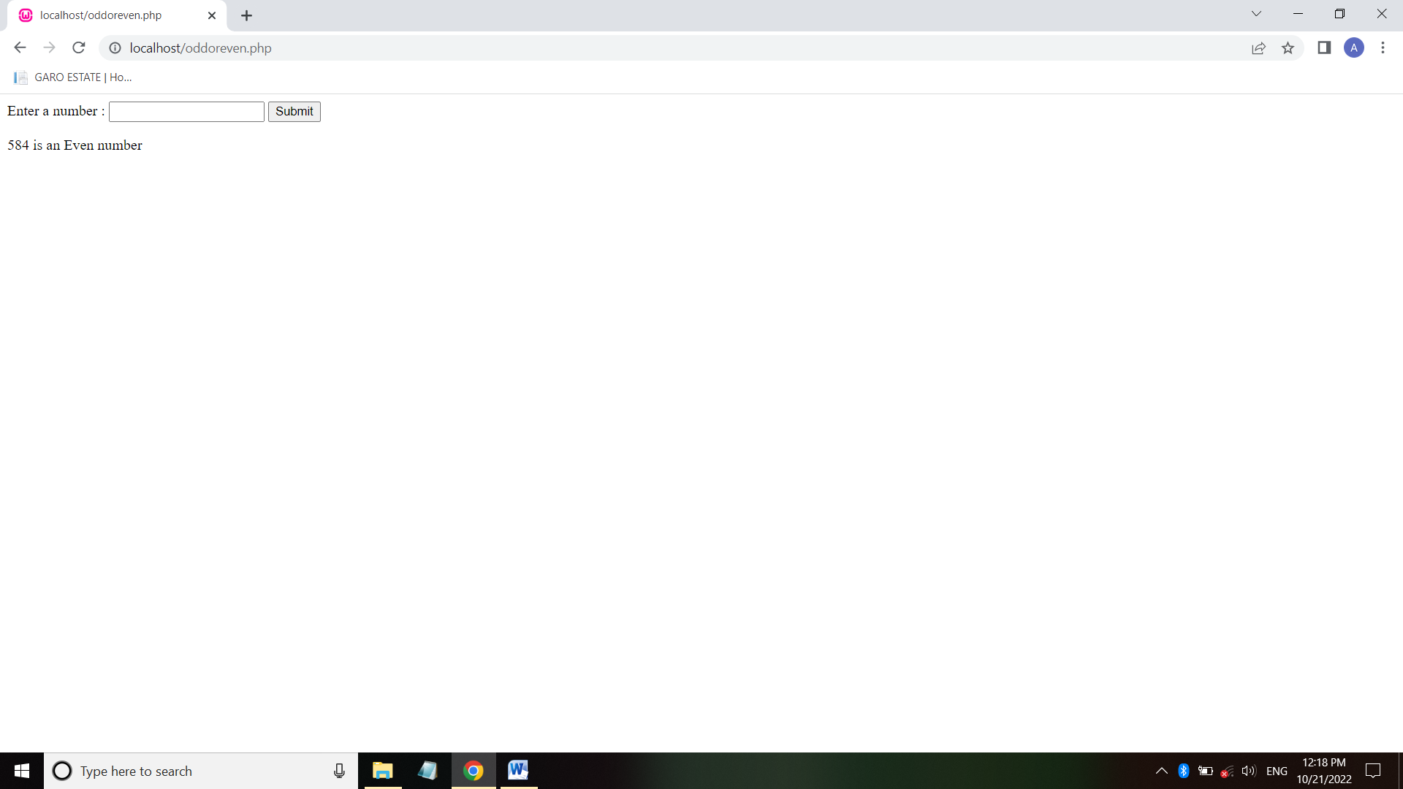

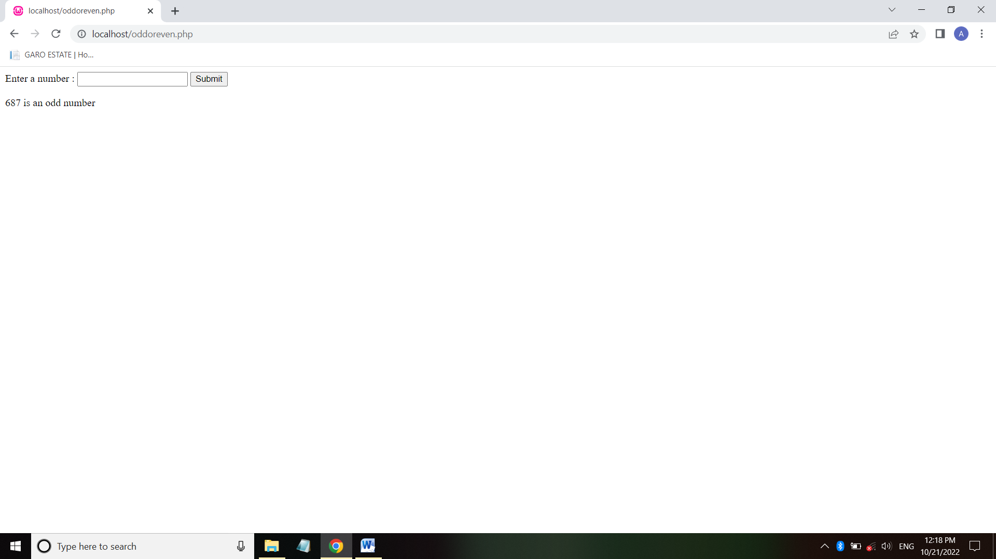

<?php

function isLeap($year)

{

return (date('L',mktime(0,0,0,1,1,$year))==1);

}

for($year=1991;$year<2016;$year++)

{

if(isleap($year))

{

echo"$year: Leap Year <br/>\n";

}

else

{

echo"$year: Not leap year <br/>\n";

}

}

?>



1. Eb bill

<html>

<head>

<title> Calculate Electricity Bill</title>

</head>

<?php

$result_str = $result = '';

if (isset($_POST['unit-submit'])) {

$units = $_POST['units'];

if (!empty($units)) {

$result = calculate_bill($units);

$result_str = 'Total amount of ' . $units . ' - ' . $result;

}

}

function calculate_bill($units) {

$unit_cost_first = 3.50;

$unit_cost_second = 4.00;

$unit_cost_third = 5.20;

$unit_cost_fourth = 6.50;

if($units <= 50) {

$bill = $units * $unit_cost_first;

}

else if($units > 50 && $units <= 100) {

$temp = 50 * $unit_cost_first;

$remaining_units = $units - 50;

$bill = $temp + ($remaining_units * $unit_cost_second);

}

else if($units > 100 && $units <= 200) {

$temp = (50 * 3.5) + (100 * $unit_cost_second);

$remaining_units = $units - 150;

$bill = $temp + ($remaining_units * $unit_cost_third);

}

else {

$temp = (50 * 3.5) + (100 * $unit_cost_second) + (100 * $unit_cost_third);

$remaining_units = $units - 250;

$bill = $temp + ($remaining_units * $unit_cost_fourth);

}

return number_format((float)$bill, 2, '.', '');

}

?>

<body>

<h1> Calculate Electricity Bill</h1>

<form action="" method="post" id="quiz-form">

<input type="number" name="units" id="units" placeholder="Please enter no. of Units" />

<input type="submit" name="unit-submit" id="unit-submit" value="Submit" />

</form>

<div>

<?php echo '<br />' . $result_str; ?>

</div>

</div>

</body>

</html>

